Flash sale effect

**Data**

The information given was a log of gamers and the orders they placed to buy diamonds to enhance their games. Three csv files—players.csv, events.csv, and orders.csv—contain the data. Finding how flash sales affect revenue in comparison to typical days and the most profitable sale is the goal of the analysis. Twice over the time period, in December and January, the flash sale was held.

Starting with some basic understanding of the data, analyzed the number of players logged in for each day, week, or month. The bar graph below shows the week numbers on the x-axis and the number of players who came online for each week on the y-axis.

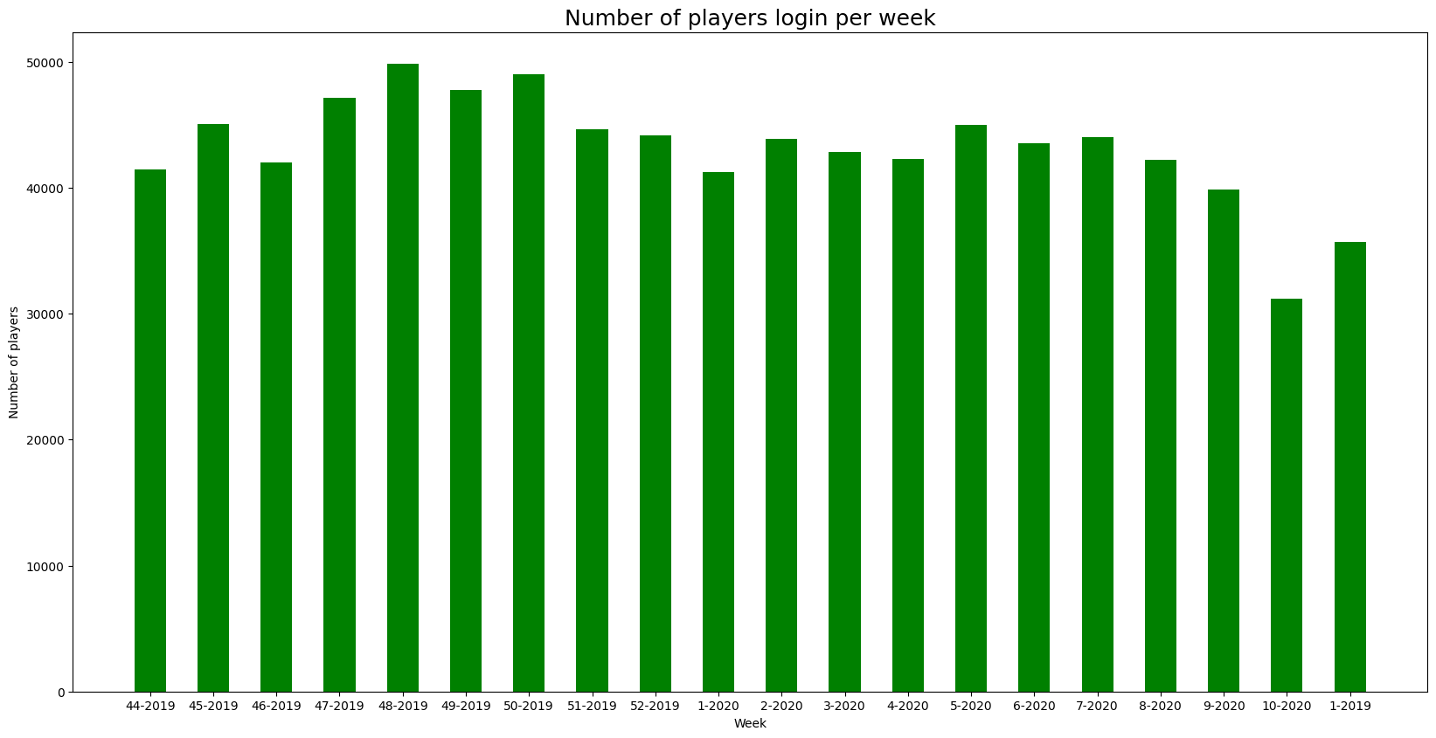

We can observe from the plot above that approximately **45000** **players** log on **every** **week**. More gamers logged in during the **50th** week of the flash sale than in the prior and following weeks, indicating that the sales are drawing some of the players' attention.

The inaugural flash sale caused almost **85000** **players** to log in during the month of **December**, according to the monthly statistics below. Following the January flash sale, it was also noted that the number of players overall dropped in February.

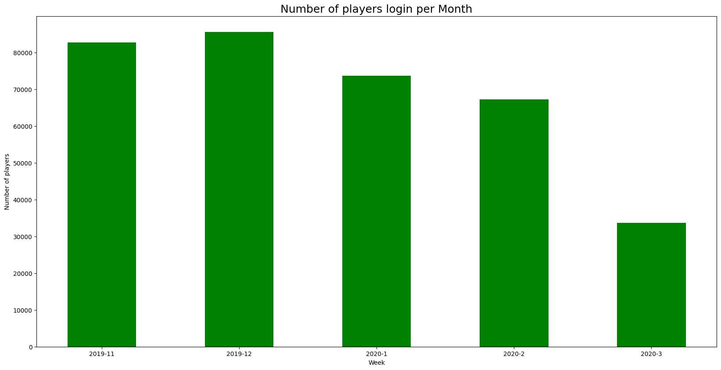

There were a total of **105413** **orders** placed by players over the time period. The bar graph showing the monthly sum of revenue from player orders is shown below. The month is represented by the x-axis, and the total revenue made throughout the entire time period is shown by the y-axis.

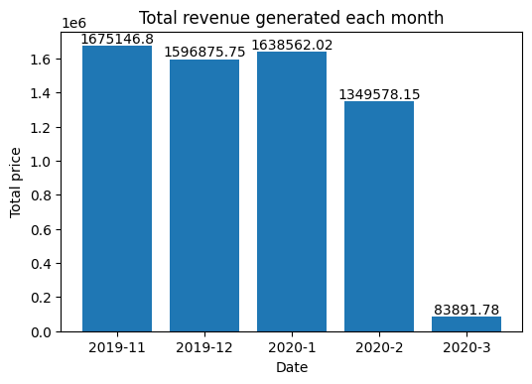

The greatest revenue was made, almost **$1.67 million**, according to the above graphic, even though there were no flash sales in **November**. A respectable **$1.63 million** in income was generated in **January**, falling slightly short of the November total.

**Task 1 - Effect of a flash sale on revenue**

The approach is taken to determine how the flash sale affected revenue is either profitable or unprofitable:

**Step 1:** Plotted the daily revenue generated over the entire time period and colored in the flash sales period specifically to distinguish the revenue from orders. The line plot illustrating daily revenue is shown below, with the order date on the x-axis and daily revenue totals on the y-axis. The purple dispersed points show how many players have logged in each day.

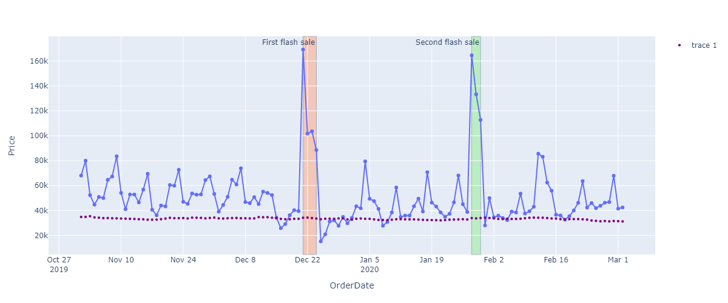

From the figure, it is clear that both of the flash sales generated a sizable profit. For instance, the total revenue generated at the beginning of the **first flash** sale on **December 21st** was **169K**. On **January 28th**, the total money from the **second flash** sale was also **$163K**, or roughly two times the average income.

**Step 2:** To determine how much extra revenue we could generate with each Flash sale – To assess the revenue profit, the dataframe is divided among time periods with and without flash sales. The accompanying plots display the daily revenue made on days. To forecast the range of possible profits, average income was also estimated.

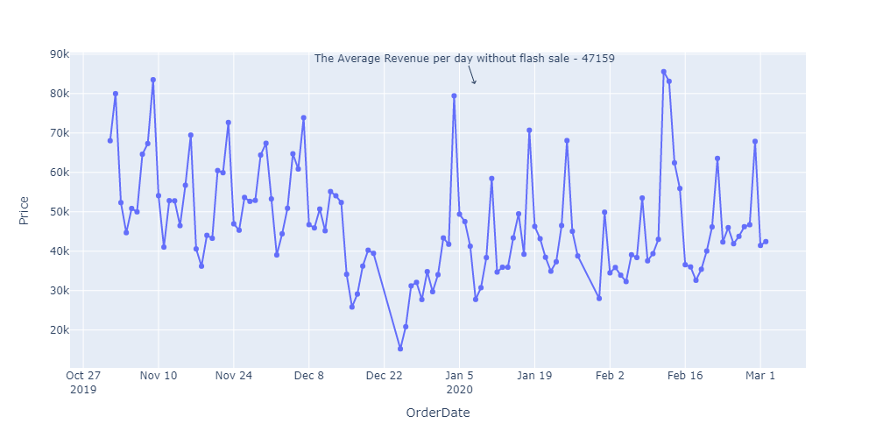

The revenue made every day on days without a flash sale is shown in the above plot. During **non-flash sale** days, the typical income is around **$48,000**.

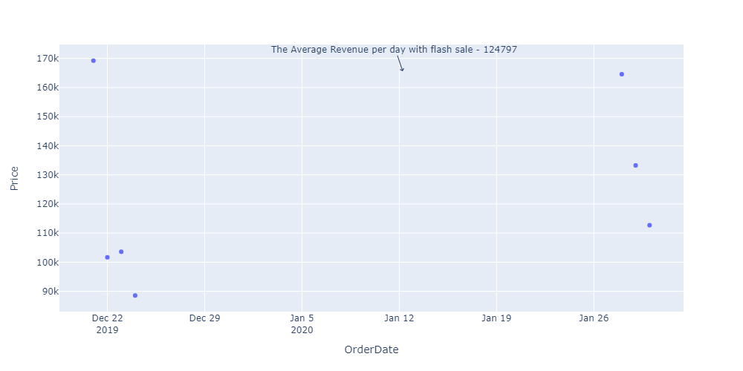

The above plot displays the daily revenue generated on days when a **flash sale** was taking place. The typical earning is roughly **$125,000** on flash sale days.

**This leads us to the conclusion that we can increase income by almost three times by doing flash sales compared to non-flash sale days.**

**Task 2 - The most successful flash sale**

The approach is taken to determine which one was the most successful Flash sale:

New columns reflecting the first flash sale or second flash sale as well as the bonus diamonds have been added to the dataframe.

To determine the rate of rise or decrease between two flash sales, the revenue difference rate is determined. The bar graph below shows the average money generated by each flash sale. The amount shown is the average revenue from the two flash sales. Which flash sale is displayed on the x-axis, and average revenue is displayed on the y-axis.

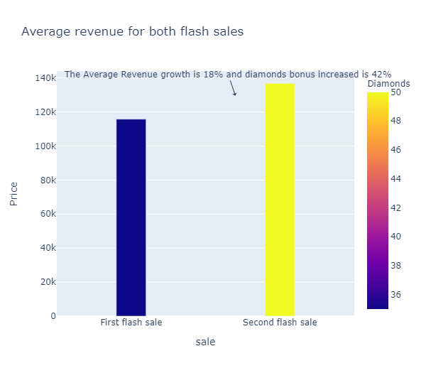

The Average revenue generated from the first flash sale is **116K** approximately and the mean revenue from the second flash sale is **137K**. The Diamonds bonus for the first sale was **35%** and for the second sale is **50%.**

**Concluding from the analysis, the revenue earned spiked from the first flash sale to the second is 18% which is from 116K to 137K. But, the diamonds bonus was increased by 42% to its original rate which is from 35% to 50%.**

**This demonstrates that despite providing diamond bonuses with a significant increase of 42%, revenue only increased by a meager 18%. The first sale is the most profitable, coming very close to the second sale with just a 35% diamond bonus.**

**Jupyter notebook:**

The jupyter notebook Flash sale effect uploaded has all the code which can be run if the following packages are installed – Pandas, Matplotlib, pyplot, and Seaborn.

The code with generating the uploaded plots and each line has been commented with its functional explanation.